Data Visualization Analysis & Insights: Aligning with Storytelling with Data Principles
Using Mock Crop Data to Demonstrate Effective Communication

1. Adherence to Storytelling with Data Principles
Cole Nussbaumer Knaflic’s framework emphasizes clarity, intentionality, and audience-centric design. Here’s how the visualizations align with these principles:

A. Clarity Through Simplicity

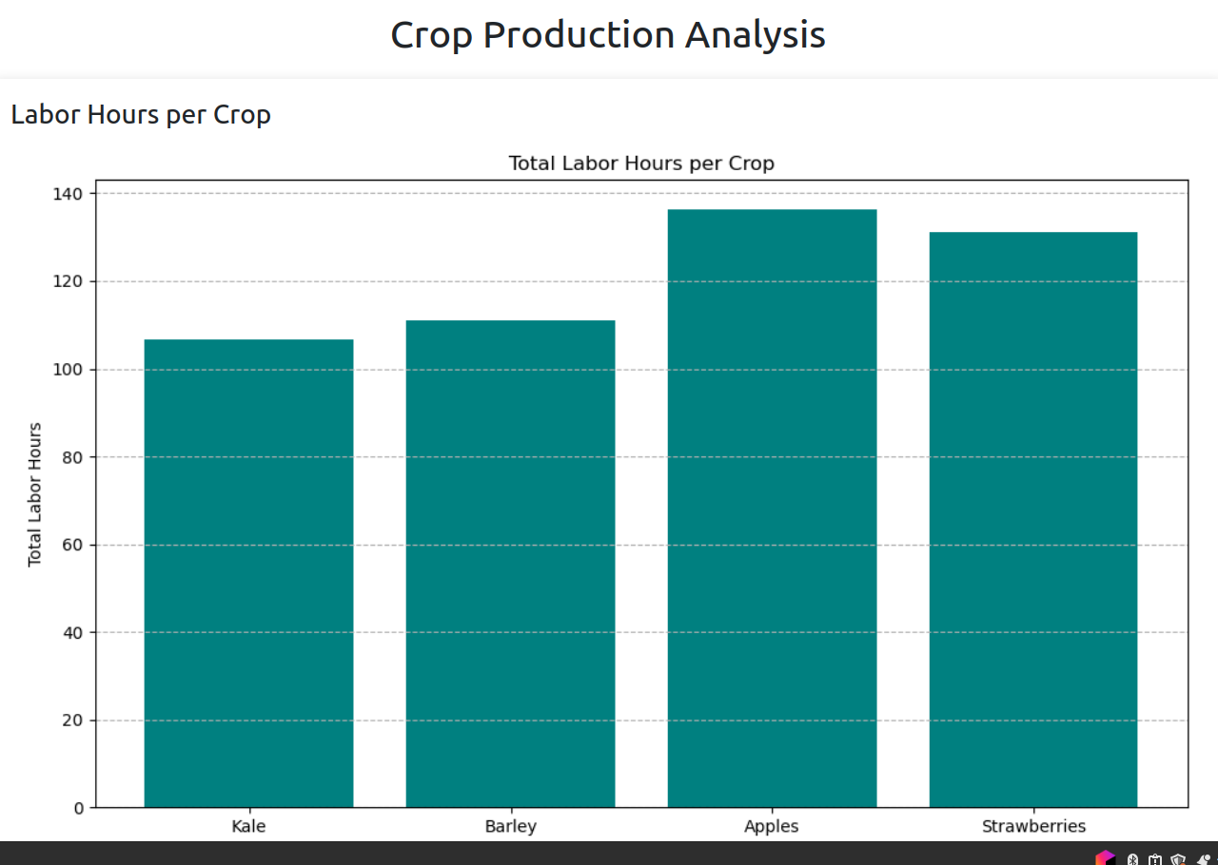
- Vertical Bar Chart (Labor Hours):
Follows the “eliminate clutter” principle by using minimal labels, a single color for comparison, and clear axis titles. The absence of gridlines or 3D effects ensures focus on the key metric: labor hours per crop.

- Horizontal Stacked Bar Chart (Harvest Distribution):
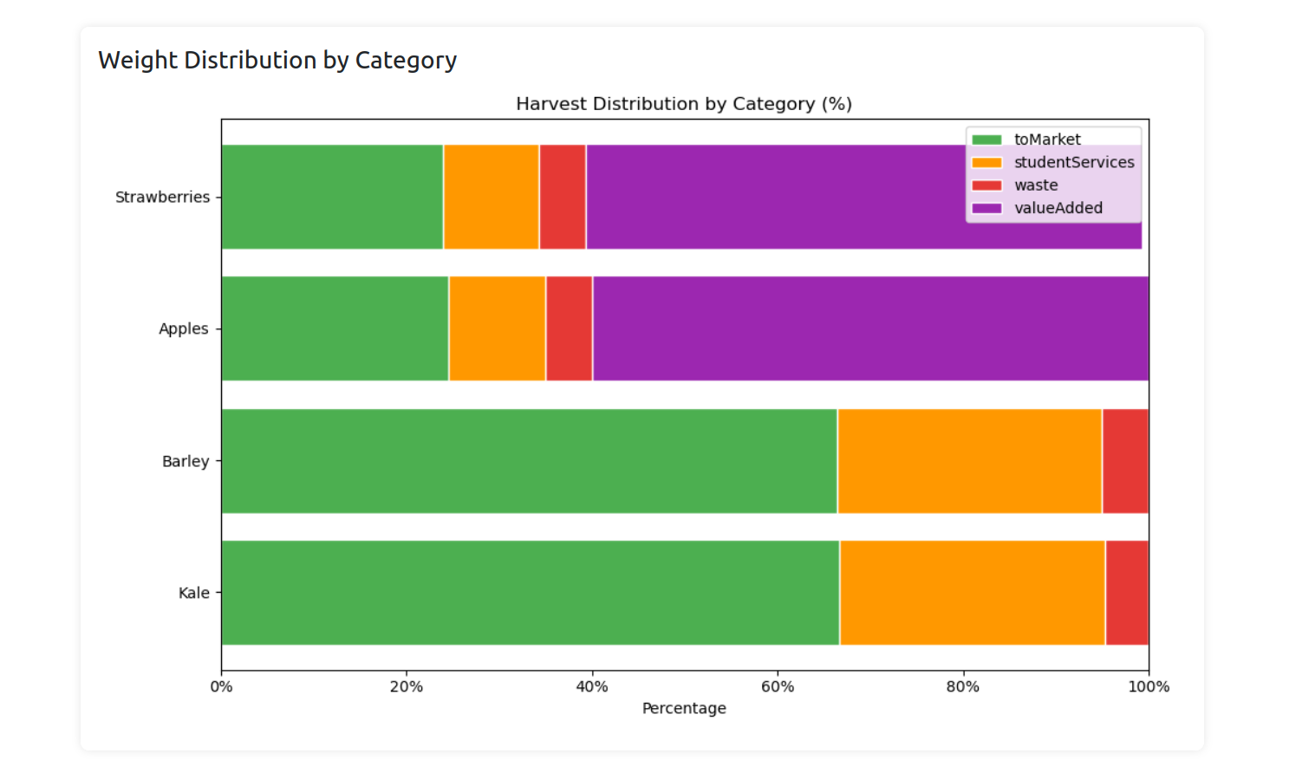
Applies “thoughtful use of color” to distinguish categories (e.g., green for toMarket, orange for studentServices), avoiding rainbow palettes that distract. Percentages are normalized to 100%, adhering to the “truthful representation” principle.
- Scatter Plot (Yield vs. Labor):
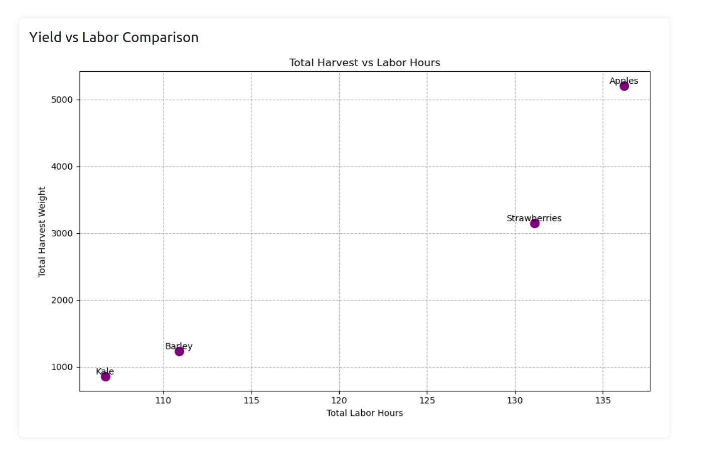

Uses “strategic annotation” to label crops directly on data points, eliminating the need for a separate legend. The axis scales are proportional, ensuring accurate interpretation of correlations.

B. Audience-Centric Focus
- Decluttering: All charts remove non-essential elements (e.g., borders, excessive ticks) to highlight trends.
- Hierarchy: Titles and labels are prioritized using font sizing and positioning, guiding the viewer’s eye naturally.
- Consistency: Uniform styling across charts (e.g., matching colors for crop types) reduces cognitive load.

C. Narrative Structure
- Order of Charts: The vertical bar chart establishes labor costs, the stacked bar explains harvest allocation, and the scatter plot ties labor to yield—a logical flow that answers: “Where is effort spent, how is harvest used, and does labor translate to results?”
- Annotations: The scatter plot’s direct labeling avoids “chart junk” while telling a story about outliers (e.g., Apples require high labor but yield disproportionately more).

2. Insights from Mock Data
Key Observations (Hypothetical):
- Labor Intensity ≠ Yield Efficiency:
  - Apples demand the highest total labor but yield 5,200 units (highest ROI).
  - Kale requires moderate labor but has the lowest harvest (820 units), suggesting potential inefficiencies.
- Harvest Allocation Trends:
  - Value-added production is only significant for Apples and Strawberries, indicating untapped opportunities for other crops.
  - Waste is lowest for Barley (5.09%)—a potential best practice to replicate.
- Labor-Yield Correlation:
The scatter plot shows no strict linear relationship, implying factors beyond labor (e.g., crop type, farming methods) influence yield.

3. Limitations & Future Directions
A. Acknowledging Mock Data Constraints:
- Small Sample Size: Only four crops limit statistical significance.
- Simplified Categories: Real-world data might include variables like weather, pest impact, or market demand.
- Data Integrity: The initial percentage discrepancies (e.g., Kale’s 105% total) highlight the need for validation in real datasets.
B. Next Steps for Real Data Implementation:
- Expand Data Collection:
  - Track labor hours by task (planting, harvesting, processing).
  - Incorporate temporal trends (seasonal yields, monthly labor fluctuations).
- Enhance Visualizations:
  - Add interactive filters (e.g., time sliders, crop toggles) using tools like Plotly
  - Integrate benchmarks (e.g., industry averages for labor/yield ratios).
- Advanced Analysis:
  - Use regression models to quantify labor’s impact on yield.
  - Perform cost-benefit analysis of value-added production across crops.

4. Conclusion
This exercise demonstrates how Storytelling with Data principles transform raw numbers into actionable insights. While mock data provides a foundational framework, real-world implementation will uncover nuanced patterns and opportunities. By maintaining a focus on clarity, audience needs, and narrative flow, future analyses can empower stakeholders to make data-driven decisions—whether optimizing labor allocation, reducing waste, or scaling value-added production.
Final Note: The transition to real data will validate hypotheses and refine visual storytelling, turning abstract numbers into compelling agricultural strategies

